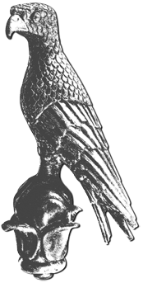
HELLENIC REPUBLIC
UNIVERSITY OF IOANNINA
International & Public Relations Office
Day Conference on the Internationalisation Strategy
at the University of Ioannina
Tuesday, 7th June 2022
Ceremony Hall «G. Mylonas»
University campus, Ioannina

09:30 - 09:45 Welcome Addresses
- A. Dimitropoulos, General Secretary, Hellenic Ministry of Education and Religious Affairs (remotely)
- A. Kachrimanis, Regional Governor of Epirus
- Μ. Elisaf, Mayor of Ioannina (remotely)

09:45 - 09:55 Internationalisation strategy of the University of Ioannina
Speaker:
- T. Almpanis, Rector of the University of Ioannina

09:55 – 11:00 The participation of the University of Ioannina in the “European Universities” initiative
Welcome addresses by the Rectors/Presidents of the partners of the alliance:
- T. Almpanis, Rector of the University of Ioannina
- University Clermont Auvergne, France
- Prof. Dr. Oliver Steffens, Vice President for Research and International Affairs, Ostbayerische Technische Hochschule Regensburg, Γερμανία
(recorded message)
- Prof. Dr. Joris Hindryckx, Rector of Vives University of Applied Sciences, Belgium (remotely)
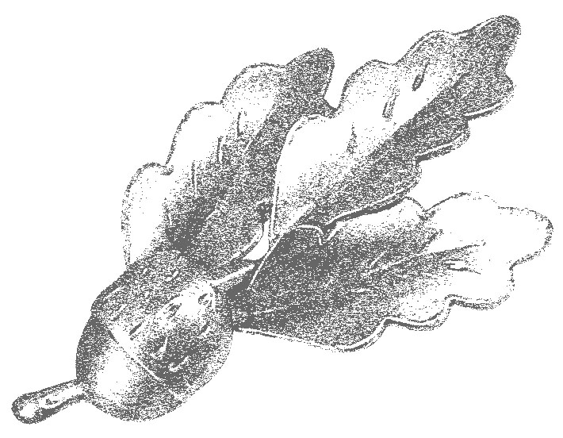
- Prof. Tarmo Sildeberg, Vice-Rector for Development, iversity of Applied Sciences, Esthonia (recorded message)
- Prof. Gunnar Yttri, Rector of Western Norway University of Applied Sciences, Norway (recorded message)
- Ovidius University of Constanța, Romania
Speakers:
- M. Zoubouli, Assoc. Prof. of the Department of Music Studies
- E. Karagiannopoulou, Dean of the School of Social Sciences, Professor of the Department of Psychology
- I. Konstantinou, Professor of the Department of Chemistry
- E. Ntzani, Professor of the Faculty of Medicine

11:00 – 11:20 Educational and research strategic partnership between the University of Ioannina and USA Universities
Speakers:
- E. Ntzani, Coordinator of the initiative, Professor of the Faculty of Medicine
- A. Batistatou, Deputy Dean of the School of Health Sciences, Professor - Head of the Faculty of Medicine
11:20 – 11:50 Educational and research strategic partnership between the University of Ioannina and UK Universities
Welcome address:
Prof. Nigel Holt, Head of Psychology, Aberystwyth University, Ηνωμ. Βασίλειο (recorded message)
Speakers:
- E. Karagiannopoulou, Coordinator of the initiative, Dean of the School of Social Sciences, Professor of the Department of Psychology
- M. Tsakali, Head Education, British Council, Greece (remotely)
- A. Avgeropoulos, Professor - Head of the Department of Materials Science and Engineering
11:50 - 12:10 Coffee break
12:10 - 12:40 Accreditation and internationalisation of undergraduate, postgraduate and PhD studies
Speakers:

- S. Nikolopoulos, Vice-Rector for Finance, Planning and Development

- G. Floudas, Dean of the School of Sciences, Professor of the Department of Physics

- J. Pagge, Dean of the School of Education, Professor of the Department of Early Childhood Education
12:40 - 13:00 Erasmus+
Speakers:
- M. Paschopoulos, Vice-Rector for Administrative, Academic Affairs and Student Welfare
- K. Plakitsi, Head of the Department of Early Childhood Education
- P. Geka, Director of International & Public Relations
- F. Koubounis, State Scholarship Foundation Officer, Erasmus+ Higher Education

13:00 - 14:30 Light lunch
14:30 – 15:00 Collaboration between Universities and Research centers in the countries of the Adriatic-Ionian basin - Uniadrion
Speakers:
- Prof. Andrea Perna, Secretary General – Uniadrion, Prof. of the Università Politecnica delle Marche (Italy) and Uppsala University (Sweden), (remotely)
- J. Pagge, Dean of the School of Education, Professor of the Department of Early Childhood Education
15:00 - 16:00 Education and research strategic partnership between the University of Ioannina and Albanian Universities
Welcome addresses by the Rectors of the Universities partners:
- T. Almpanis, Rector of the University of Ioannina
- University of Tirana, Albania
- Prof. Assoc. Merita Isaraj, Vice/Rector for Scientific Research and International Relations, Eqrem Çabej University of Gjirokastra, Albania (in-person)
- Prof. dr. Dhimitri Bello, Rector, University ‘Fan S. Noli’ Korçe (recorded message)
- ‘Ismail Qemali’ Vlora, Albania
- Prof. dr. Besnik Aliaj, Rector, ‘Polis’ University, Albania (remotely)
- University of Medicine Tirana, Albania
- Aleksandër Moisiu University of Durrës, Albania
- University of Shkodra “Luigj Gurakuqi”, Albania
Speakers:
- H.E. S. Philippidou, Ambassador of Greece in Tirana, Albania (in-person)
- N. Mylonidis, Professor - Head of the Department of Economics
16:00 - 17:15 Round Table: Evaluation of Universities’educational and research achievements
Speakers:
- T. Almpanis, Rector of the University of Ioannina
- S. Katsanevas, Professor of Paris VII – Denis Diderot University & Director of the European Gravitational Observatory (remotely)
- S. Georgatos, Vice-Rector of Research and Lifelong Learning
- L-P. Kontis, Professor of the Department of Computer Science and Engineering
17:15 Closing Remarks
Διεύθυνση Διεθνών και Δημοσίων Σχέσεων • Πανεπιστημιούπολη Ιωαννίνων • 45500 Ιωάννινα
Τ. 26510-07105, 07520, 07106, 07107 • E-mail: piro@uoi.gr

